October 14th, 2017

The Practitioner Scholar Journal
Argosy University College of Counseling, Psychology and Social Sciences
Dr. Joffrey Suprina, Editor

Dear Dr. Suprina,

As part of the submission of my original article, entitled Loss, meaning making, & reconstruction of narratives in adults enduring tinnitus exacerbated by exposure to sound, this letter is to certify that I have followed ethical guidelines in accordance with those set forth by the American Psychological Association.

In appreciation of the mission and scope of The Practitioner Scholar Journal as the official journal of the Argosy University College of Counseling, Psychology and Social Sciences, I am grateful for your consideration and look forward to receiving feedback from peer review.

Considering that this is my first submission to The Practitioner Scholar Journal, please do not hesitate to contact me with any questions or concerns regarding this submission.

Sincerely,
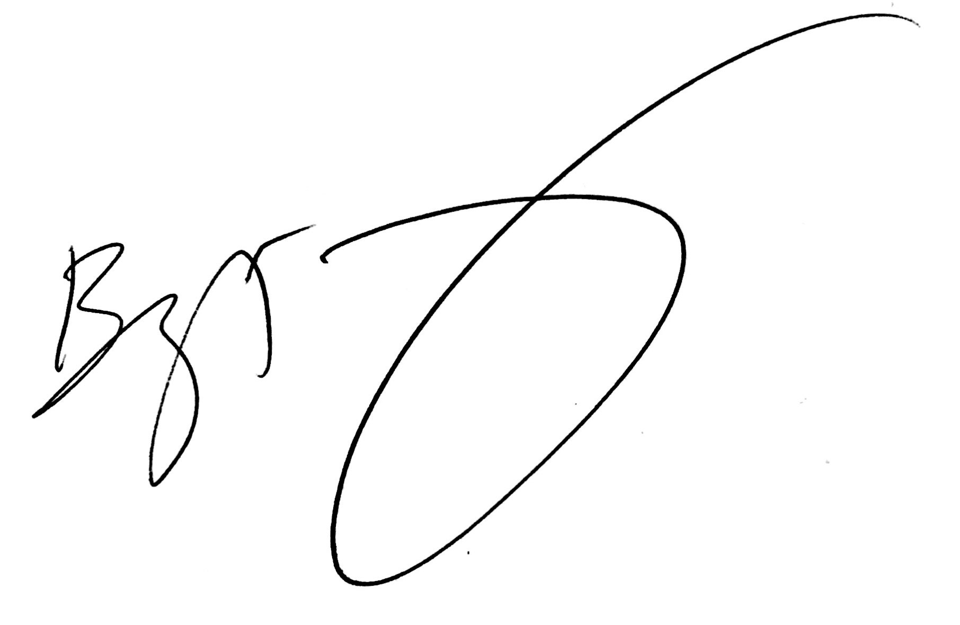
Benjamin Greenberg, M.A.
American School of Professional Psychology,
Argosy University San Francisco Bay Area
1005 Atlantic Ave, Alameda, California 94105

